APTECH APROTRAIN



EPROJECT 3 REPORT

Environmental Survey

|  |  |  |
| --- | --- | --- |
| Members | PHUONG BUI VIET | Student1149206 |
|  | NGUYEN DO TRONG | Student1139862 |
|  | HANH TRAN XUAN | Student1139899 |
|  | HUYEN TRAN PHUONG | Student1148550 |
|  | TUAN HA VIET | Student1139901 |

Contents

Introduction 3

1. Project Information 3

2. Problem Statement 3

3. Hardware/Software Requirements 3

Acknowledgements 4

Project Analysis 6

1. Requirement Specification 6

2. Backlogs 8

Project Design 9

1. Business Function Diagram 9

2. Dataflow Diagram 10

2.1. Context DFD 10

2.2. DFD Rank 0 10

3. Entity Relationship Diagram 11

3.1. Entities Declaration 11

3.2. Notes: 11

4. RM Diagram 12

5. Sitemap 12

6. UI/UX Design 13

Screenshots 14

Source Code 19

Developer’s Guide 20

1. Environment Requirements 20

2. API Up & Running 20

3. Client Up & Running 20

3.1. Admin Interface 20

3.2. Visitor Interface 20

Tasks Sheet 21

# Introduction

## 1. Project Information

* Project Name: Environmental Survey
* Project Platform: Web

## 2. Problem Statement

Our client is the educational institute, which wants to enlighten the students of that institute with the precautionary measures related to the environmental protection. So they conduct several seminars, lectures, etc. to the students. They now want to implement some tasks so that the attention of the young generation will be attracted towards taking necessary steps for taking care of the environment, as it relates to the health of the public. They started providing the seminars for free, for the students of the institute and encouraging the students to provide and interactive seminar sessions by visiting to some locations. Also they have started conducting surveys through papers and used to distribute the prizes for the first three students based on the marks secured in the survey and also based on the effective participation in visiting to locations for provided interactive sessions regarding the precautionary measures in protecting the environment. They wanted to reduce the paper consumption for conducting the surveys and want to provide a survey portal where the surveys will be held. So they have approached us to help them in building the survey portal for them.

## 3. Hardware/Software Requirements

* A minimum computer system that will help you access all the tools in the courses is a Pentium 166 or better
* 64 Megabytes of RAM or better
* Windows 98 (or higher if possible)
* Java Virtual Machine
* Notepad/HTML editor/Java editor Dream weaver/JavaScript
* .Net / J2EE JSP / j2sdk1.4.1_02 (or later) / Servlets
* .Net Framework / EJB / Struts
* JDBC /SQL Server 2000 (or later) / Oracle 9i / MS Access JDBC Driver

# Acknowledgements

We would like to send our sincere thanks to:

* The Aptech training system has provided the topic as well as support in many aspects of our project process.
* Faculty Hoang Nguyen Duc, who gave us a great deal of support and guidance during the process from the beginning until the completion of the project.

Project Synopsis

This website is used for running many survey campaigns about the topics relate to environment problems.

The Admin interface provides all functions to manage visitors and surveys also all static resources (FAQs, support information,…).

The Visitor interface contains landing pages show surveys catalog, environment illustrations, etc… and provides all functions to do survey and statistic survey results.

# 

# Project Analysis

## 1. Requirement Specification

1. The website should perform three different functionalities.

* Admin
* Faculty or Staff
* Students

1. The website should have the menu which should contain the following links

* Home Page
* Login / Register
* Survey Board (Lists the survey and the competition details)
* Edit Profile
* Support FAQ s

1. Through login section and registering section, one should be able to either register online or login through the Account user id and password.
2. Through the username and password specified, the website should be able to judge or recognize the type of user functionality (Admin, or Faculty or Staff or Student), and the corresponding website functionality should be opened, so that the admin can access only the admin section, the faculty or staff can access the faulty or staff section, etc.
3. Once registered the admin will have the right to accept or decline the request for the registration. One can login through the website only when the registration is accepted by the admin.
4. Also the admin will have the right for deleting the username and the password (It will be applicable only when the student or staff or the faculty resigns from their respective duties)
5. While registering it should ask the following

* Name
* Roll No. or Employee Number (It is required because the survey panel is only for the students, faculty and the staff of the institution)
* Class
* Specification
* Section
* Admission Date (For students) or Date of Joining (For faculty and staff)

1. Like the Admin will have the following functionalities

* Place new survey for the faculty or staff
* Place new survey for the students.
* Delete survey
* Accept or decline the registration request (Here the admin will check whether the person who registered belongs to the institution
* Delete the User (where the details of the person who resigned from the duties provided by the institution will be deleted and he cannot have the right to access the website from then)
* Place a competition, or list the names of the members who have won the prize for the previous surveys.
* Enter new FAQ s
* Edit FAQ s
* Edit Support Information

1. On the home page of the website it should also include the details of the competitions that are to be held. Also the new surveys should be displayed in a brief and a link to participate in the survey.

*Note: Those who have logged into the website can only participate in the survey others cannot participate.*

1. On the home page the new surveys that are to be conducted and the total surveys took place for the faculty or staff or for the student till date, and the number of surveys participated by the respective users (faculty or staff and the students), should be recorded.
2. On the Support Page the contact details, if any technical help, required in the participation of survey has to be displayed.
3. On the FAQ s Page the following details are to be included

* How to register for the survey? How to participate in the survey?
* How will I be intimated with the new survey?
* What if it gives error, after participating in the entire survey, and clicked on the submit button at the last for submitting the survey?
* Why I am unable to participate in the survey? (Two reasons : 1.Not the registered user, and 2.Technical Problem)
* Why my registration request is not accepted?
* Will there be any benefit if participated in the survey? How to participate in the competitions?
* What if there are some arrears in participating the survey?

1. For the faculty or staff and the student login sections, on the menu there should be another link called Effective Participation , through which one can mention the survey details in detail like what are the seminars conducted by the user, the location at which the seminar is conducted, number of participants, etc.

## 

## 2. Backlogs

|  |  |
| --- | --- |
| Admin | Authenticate |
| Create surveys |
| Update surveys |
| Delete surveys |
| Manage visitor registered |
| Manage FAQ, support information |
| Student/Faculty | Authenticate |
| Read/filter/search surveys |
| Do surveys |
| Read survey results and top survey results |
| Edit profile |

# Project Design

## 1. Business Function Diagram

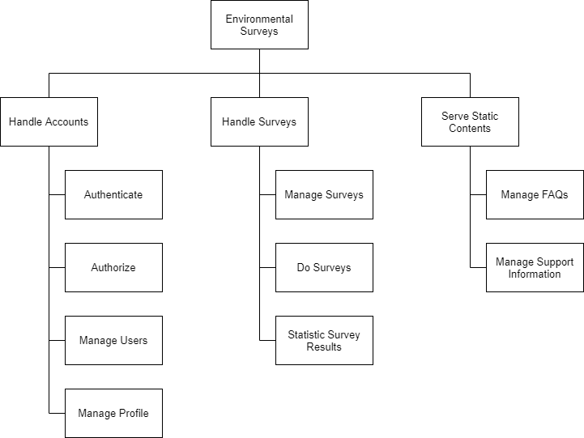

1. Business Function Diagram

1. **Handle Accounts:** Handle functions relate to user accounts

* Authenticate: Login/logout
* Authorization: Authorize which route visitor can access
* Manage Users: Manage visitor (Ban, Re-active, …)
* Manage Profile: Edit personal profile

1. **Handle Surveys:**

* Manage Surveys: Show/add/edit/remove/filter/search surveys
* Do Surveys: Submit survey
* Statistic Survey Results: See personal results and statistic top results each survey

1. **Serve Statistic Contents**

## 2. Dataflow Diagram

### 2.1. Context DFD

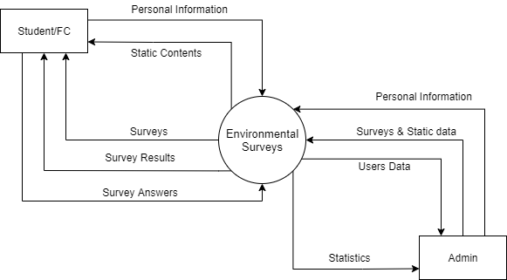

2. Context Dataflow Diagram

### 2.2. DFD Rank 0

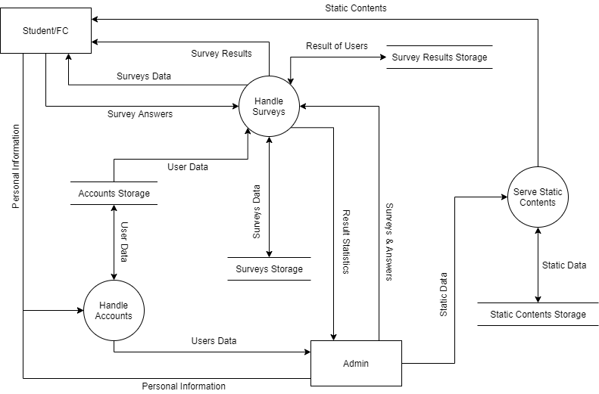

3. Rank 0 Dataflow Diagram

## 3. Entity Relationship Diagram

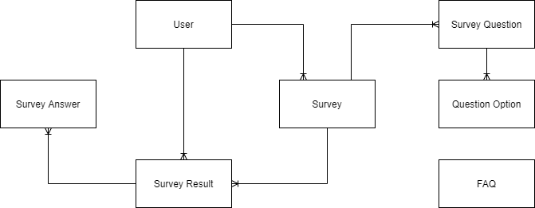

4. Entity Relationship Diagram

### 3.1. Entities Declaration

* **User:** Account of admins and visitors (students, faculty).
* **Survey:** An survey run for a seminar, like a quiz test, has many question with options for visitor choose.
* **Survey Question:** Questions in each survey.
* **Question Option:** Options in each question.
* **Survey Result:** Contains list of options a visitor choose for a survey and mark this user get.
* **Survey Answer:** Corresponding to Question Option the visitor choose.
* **FAQ:** FAQ.

### 3.2. Notes:

* **1 User – n Survey:** 1 admin create many surveys, 1 survey can be created just by 1 admin.
* **1 User – n Survey Result:** 1 visitor can do many surveys so has many survey results, 1 survey result is belong to 1 visitor.
* **1 Survey – n Survey Question:** 1 survey contains many questions, each question is belong to 1 survey.
* **1 Survey Question – n Question Option:** 1 Question contains many options, each option is belong to 1 question.
* **1 Survey – n Survey Result:** 1 survey has many results belong to different visitors, 1 result is belong to 1 specific survey.
* **1 Survey Result – n Survey Answer:** 1 survey results is a list of option 1 visitor chosen, and each option corresponding to 1 survey answer.

## 4. RM Diagram

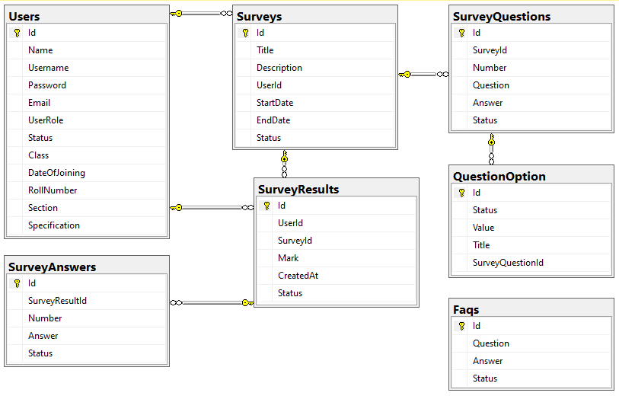

5. RM Diagram

## 5. Sitemap

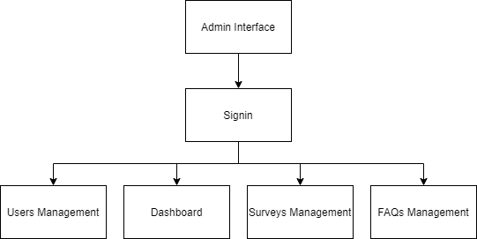

6. Admin Interface Sitemap

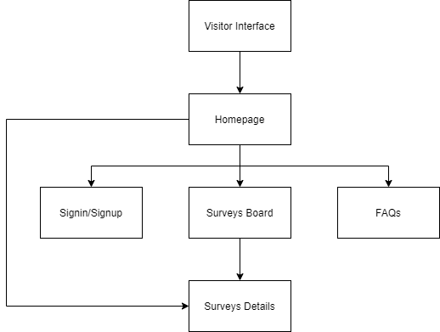

7. Visitor Interface Sitemap

## 6. UI/UX Design

UI/UX design is located on: <https://www.figma.com/file/Z90DDi1kX0tEZAQCFrmwDm/Ecosite?node-id=0%3A1>

# Screenshots

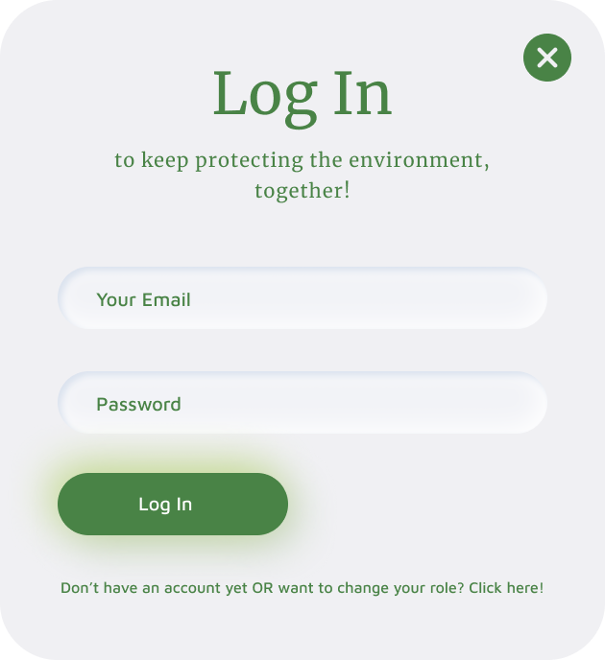

8. Login Card

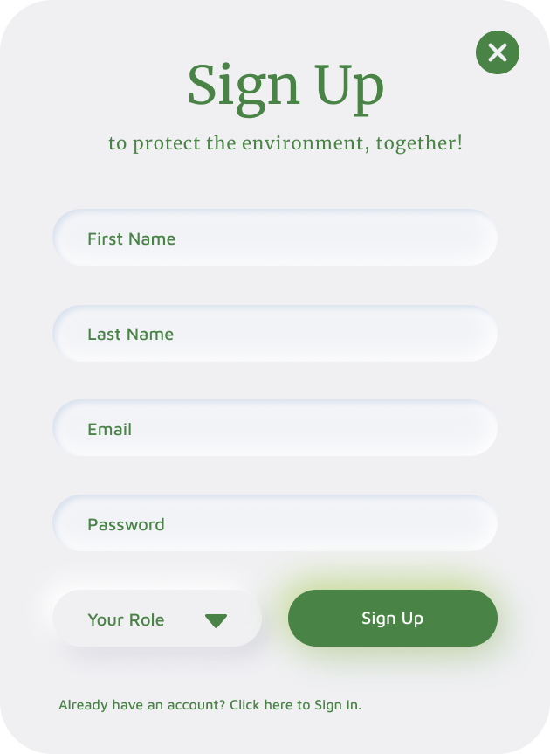

9. Signup Card

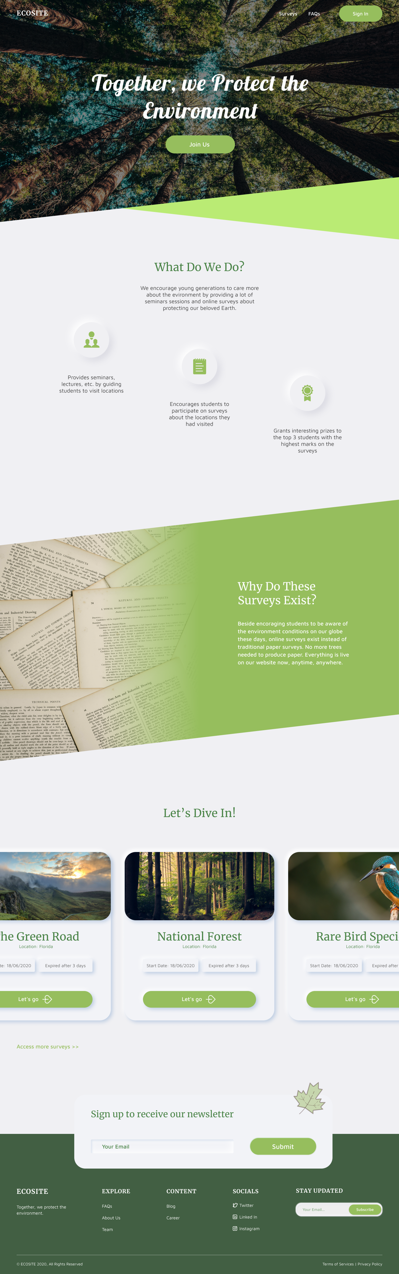

10. Homepage

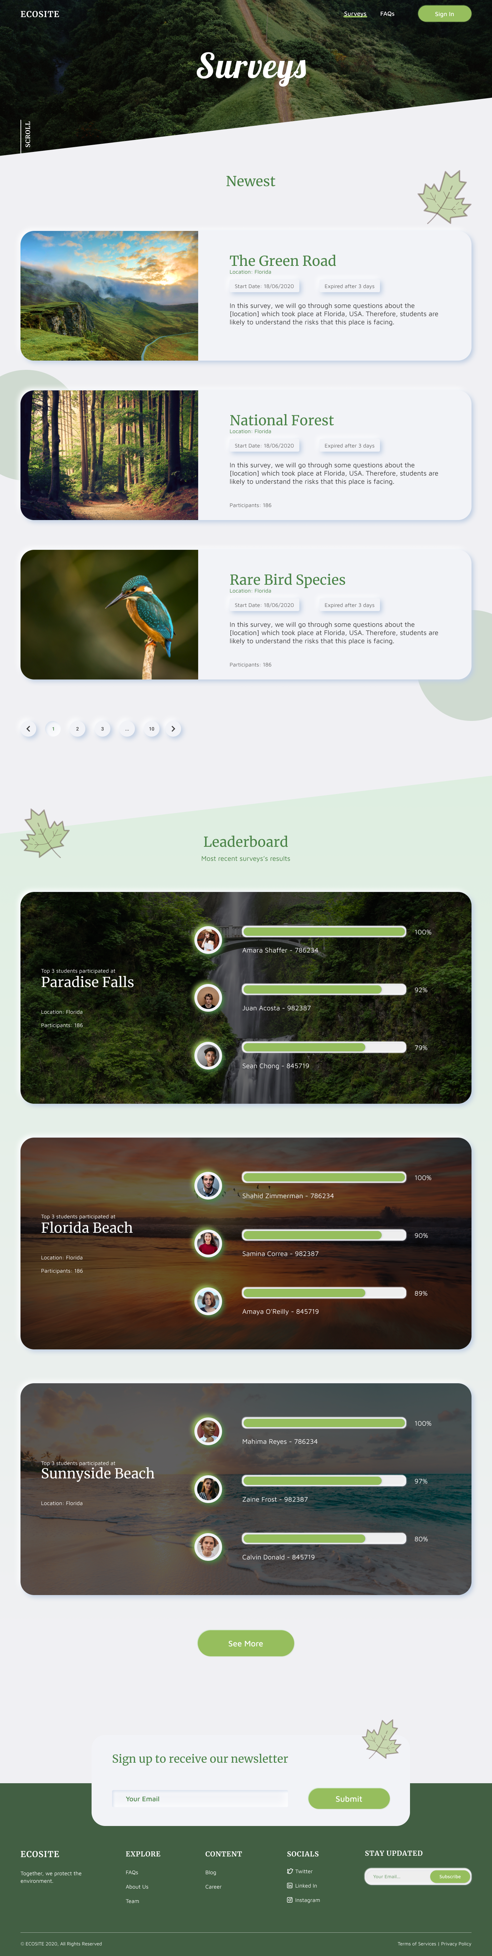

11. Surveys Board

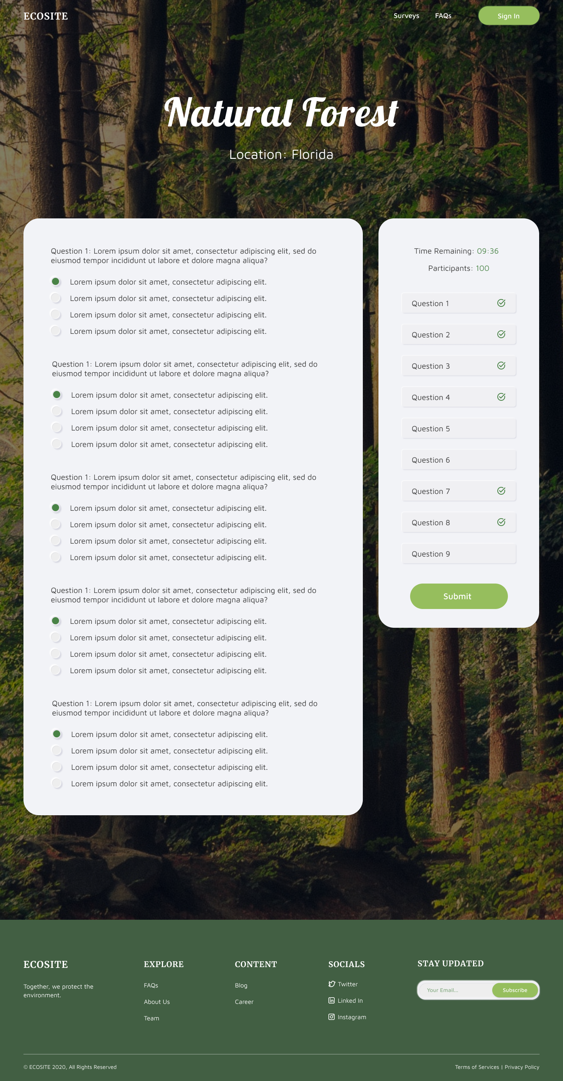

12. Survey Details Page

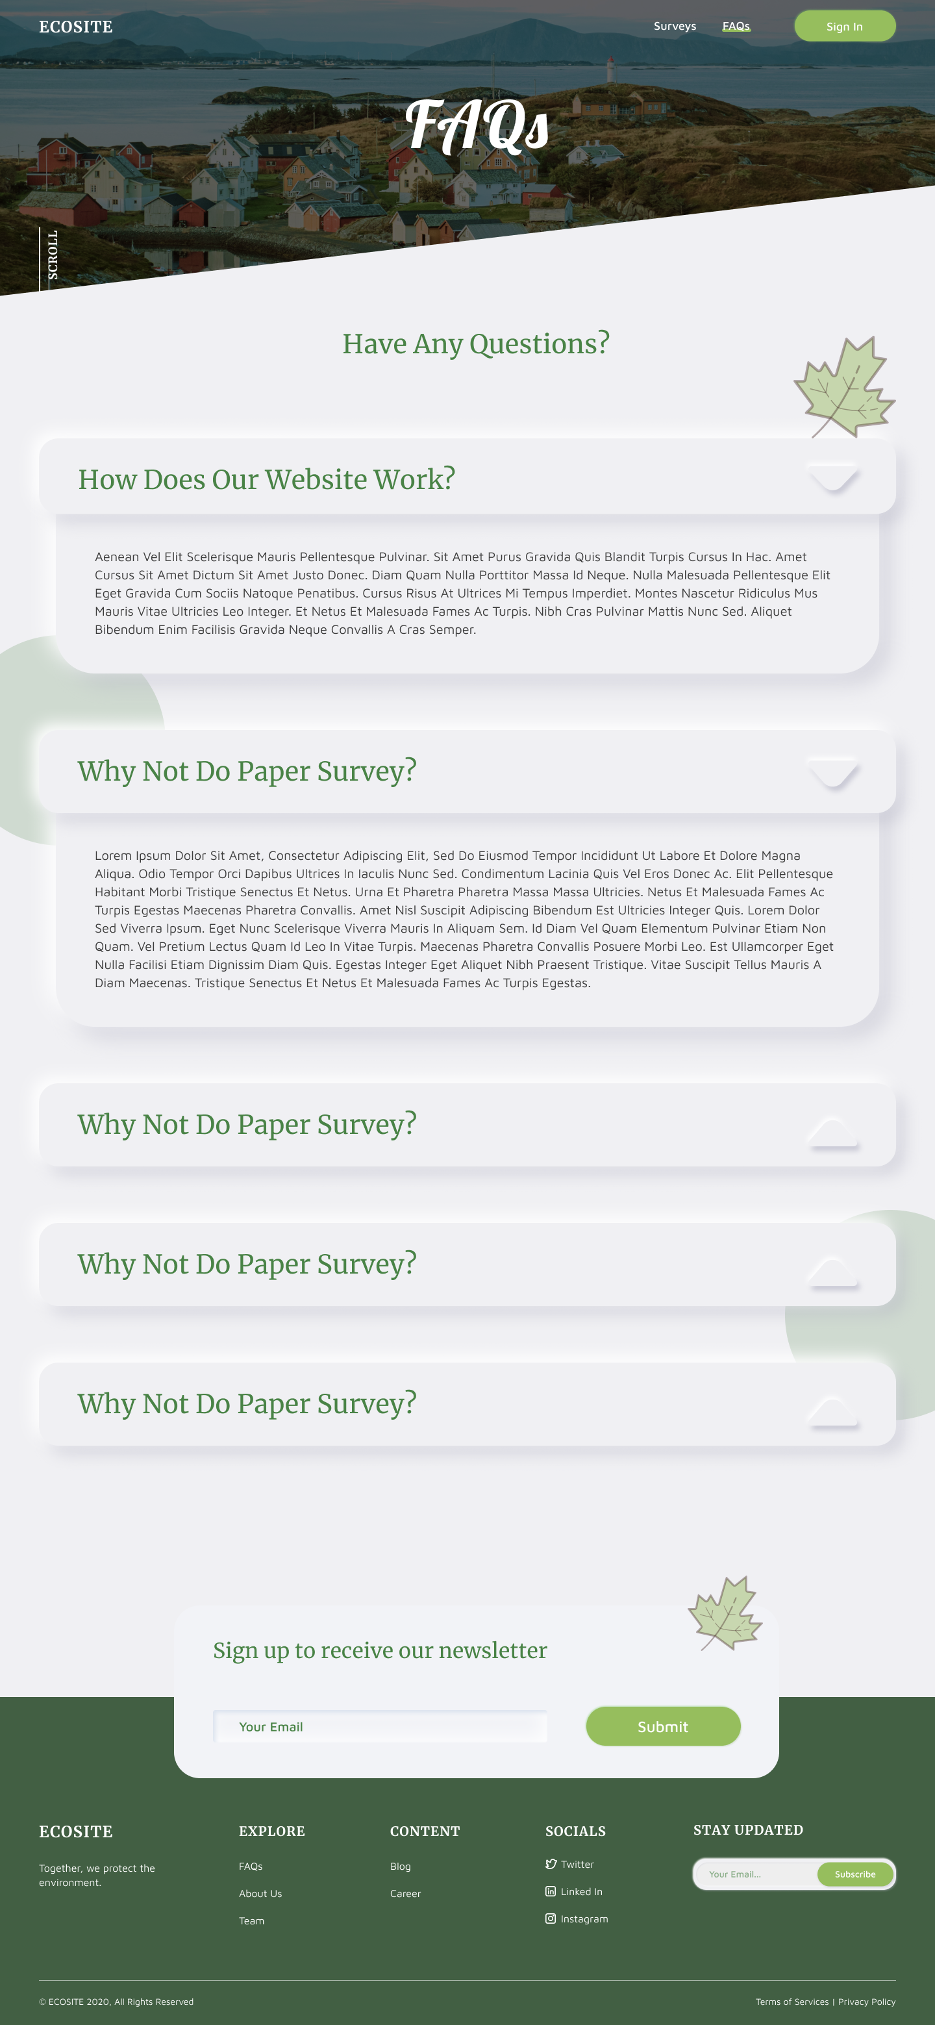

13. FAQs

# Source Code

All our source code is located on [GitHub](https://github.com/)

* Back-end (ASP.NET Core API): <https://github.com/censodev/aptech_eproject3-api>
* Front-end:
* Visitor Interface (ReactJs): <https://github.com/hanhaaaaaa/aptech_pri_sem3>
* Admin Interface (VueJs): <https://github.com/nguyenpr9/adminEnvSurvey>

# Developer’s Guide

## 1. Environment Requirements

Docker Desktop (Windows)

Nodejs v12.x

## 2. API Up & Running

Clone project from <https://github.com/censodev/aptech_eproject3-api>

Open solution with Visual Studio

Clean and build solution

Locate to root folder and run file ***docker.build.sh*** then run file ***docker.run.sh***

## 3. Client Up & Running

### 3.1. Admin Interface

Clone project from <https://github.com/nguyenpr9/adminEnvSurvey>

Locate to root folder, open terminal and run commands:

***npm install***

***cp .env.product .env***

***docker-compose up -d –build***

### 3.2. Visitor Interface

Clone project from <https://github.com/hanhaaaaaa/aptech_pri_sem3>

Locate to root folder, open terminal and run commands:

***npm install***

***yarn start***

# Tasks Sheet

|  |  |
| --- | --- |
| **Task** | **Member** |
| Requirements analyze | Huyen Tran Phuong |
| Phuong Bui Viet |
| Create backlogs, task scheduler | Huyen Tran Phuong |
| System architecture design | Phuong Bui Viet |
| UI/UX design | Huyen Tran Phuong |
| API coding | Phuong Bui Viet |
| Visitor UI coding | Hanh Tran Xuan |
| Tuan Ha Viet |
| Admin UI coding | Nguyen Do Trong |
| Testing | Tuan Ha Viet |
| Report | Phuong Bui Viet |
| Huyen Tran Phuong |